Government and Politics

A LEVEL GOVERNMENT AND POLITICS

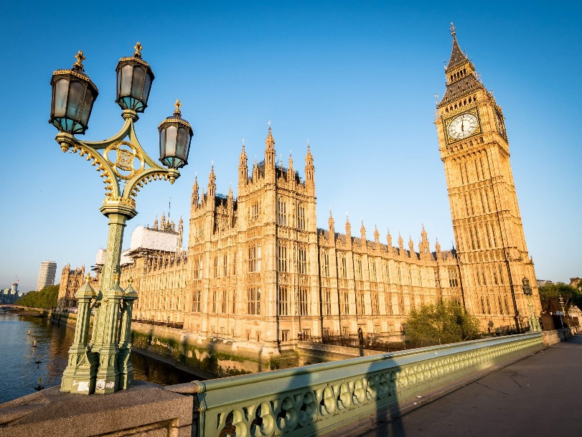

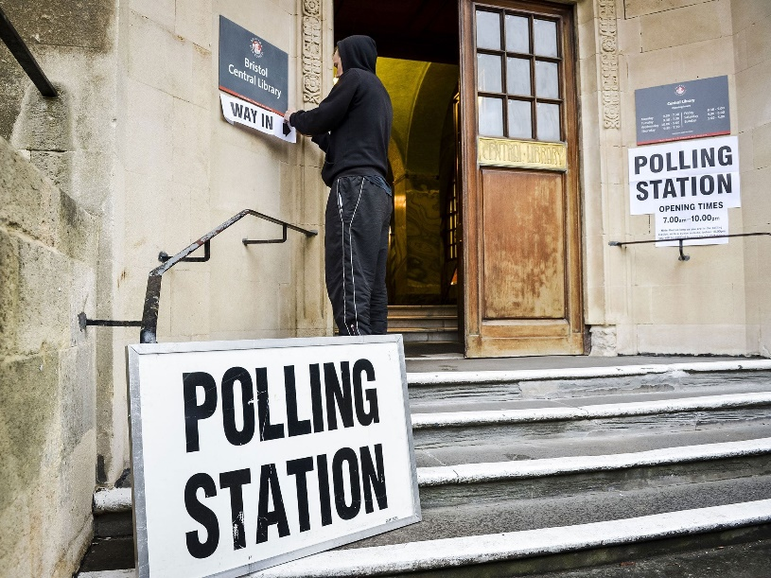
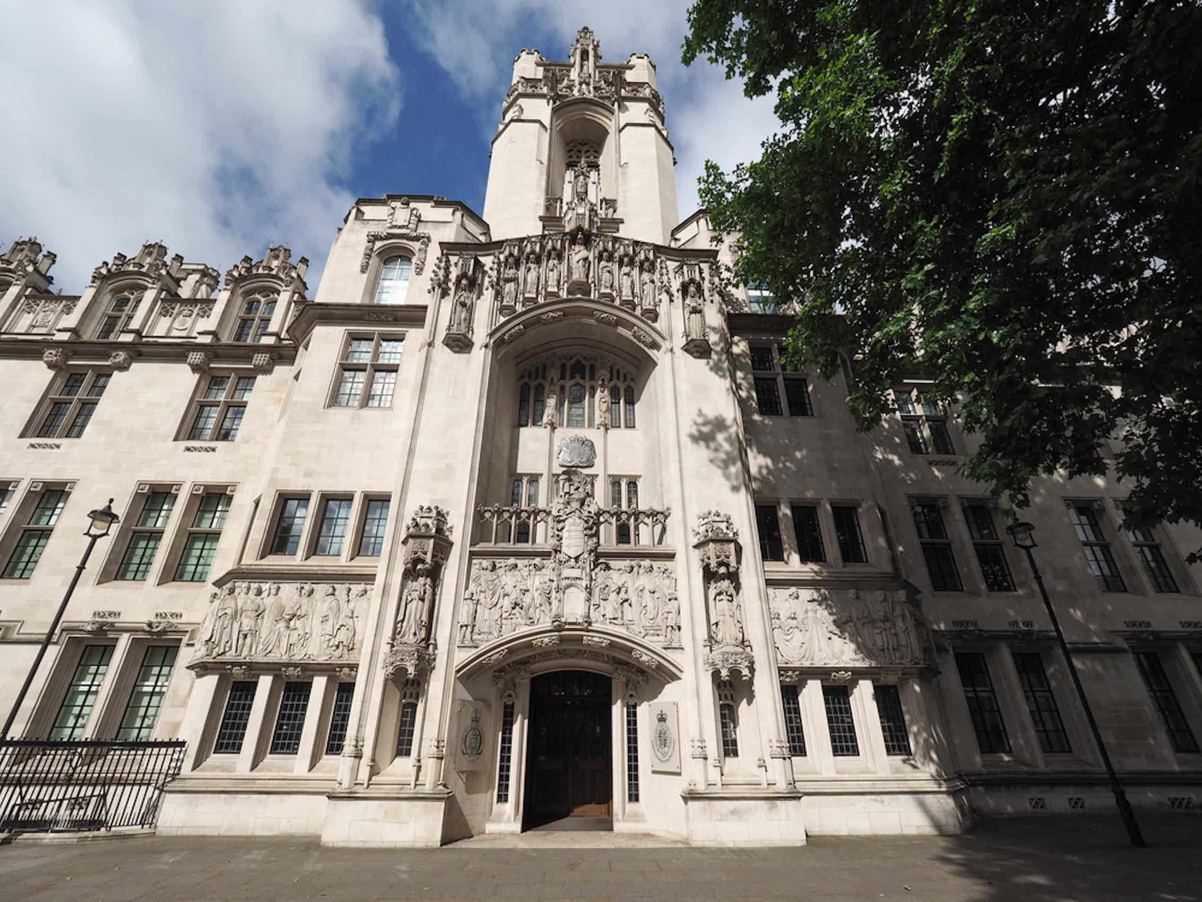
WHAT WILL I STUDY?

The course specification can be accessed here (Edexcel Specification):
A level Politics - Specification (pearson.com)

The course is split into three distinct areas, two of which you will study in Year 12 and the other area you will study in Year 13.

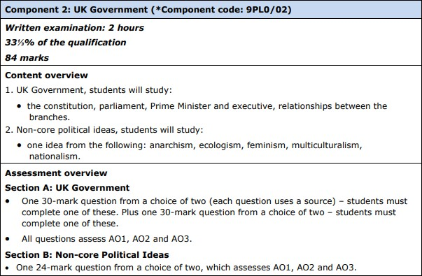
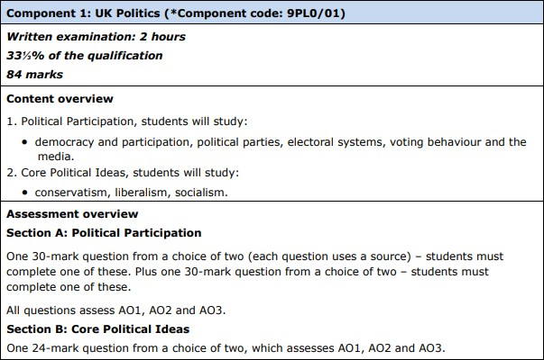
Year 12- You will study feminism
Year 12

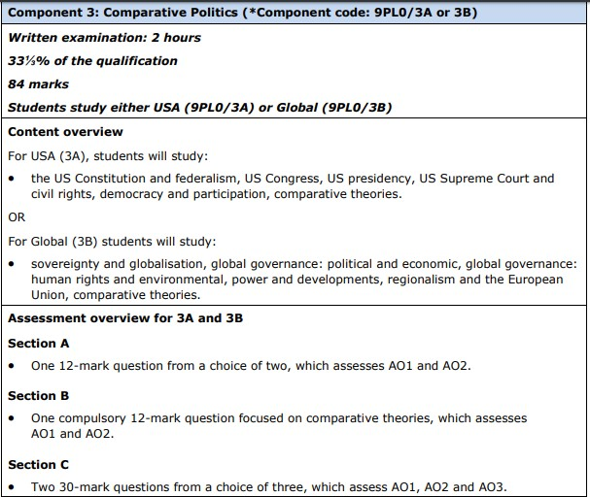
Year 13

The skills you will develop studying politics:

- Knowledge and understanding of different political ideas , concepts, structures and processes, the relationship between them and how they work at different levels.
- An ability to interpret and analyse political information in various forms and from various sources, and to apply a range of political ideas concepts and theories.
- An ability to evaluate arguments, theories, values and ideologies to explain political behaviour and suggest solutions to controversial issues.
- The skills to organise and present an argument with relevance, clarity and coherence using good English.

SUMMER TRANSITION WORK

We are so excited to hear that you are hopefully going to be joining us in September to study A Level Government and Politics.
This booklet will give you a brief introduction to the course layout and help you to start getting to grips with some of the key terminology and ideas in preparation for September.

The first term there are 2 topics we will study. These 2 topics will contribute towards the first 2 final exams you will sit in the summer of Year 13.

These two topics are:

- Democracy and Participation (Why people get involved in politics)
- The UK Constitution

Please complete the 4 tasks below and bring this completed workbook with you in September. We have also added some links and information about future Career Pathways in Politics, with links for you to do some research!
Best wishes, Team Gov and Pol

*SUMMER TRANSITION WORK HAND IN WEEK: 11th – 15th SEPTEMBER

Task One – Political Voting Systems

Task:
You need to research at least 4 different voting systems.
You should give examples of countries or jurisdictions that use these systems.
You should provide 2 advantages and 2 disadvantages of using these systems.

Challenge: Is there any ways that these systems could be changed/ adapted to make them more beneficial to certain areas of society?

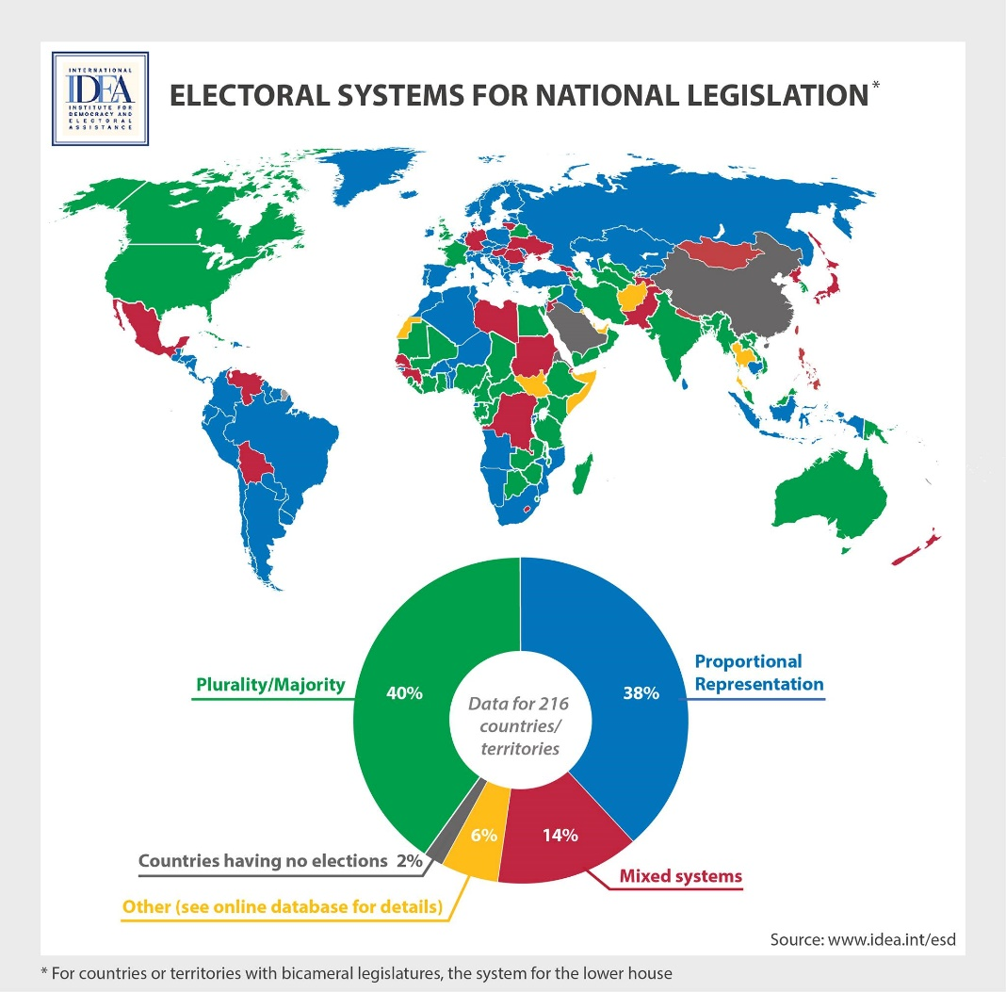

Task Two – Prime Minister and His Cabinet
Politics is a subject which cannot be unplugged from news and current affairs- it is always changing!
Task:
Research the Prime Minister and his Core Executive. (this means his cabinet office).
You should draw yourself a diagram to represent this, considering what departments each of the cabinet ministers lead. You will be assessed on your knowledge of the key individuals when we return in September.
Challenge- You might want to also keep an eye on any changes that occur in this over the summer- why did the ministers change and what impact might this have had on the prime minister?

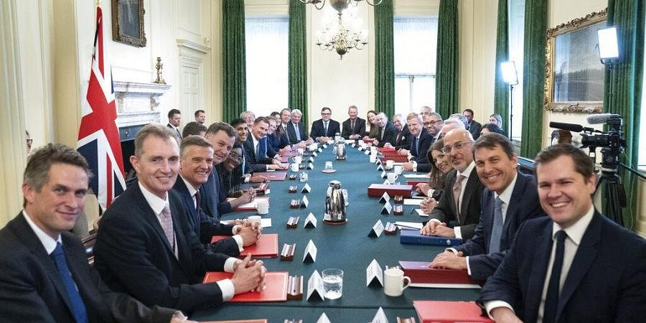

Task Three – Parties and Issues
To start, you should quickly research the Conservative, Labour and Liberal Democrat parties. What do they stand for? Then, use the internet, textbooks and your imagination to create your own political party which will stand at the next election. You should include the party’s name, some points as to what the party stands for and three key policies your party will introduce if they are elected including why you would introduce them. These policies will cost money - will people have to pay more tax or would you make savings elsewhere? You have to justify your decisions. Some topics to consider might be:
Health, Crime, Housing, Education, Immigration

Go to these links here for the UK’s three major parties: https://www.bbc.co.uk/news/election-2019-50524262 https://www.bbc.co.uk/news/election-2019-50501411 https://www.bbc.co.uk/news/election-2019-50459123
These links summarise their key manifesto policies in the 2019 general election

Task Four – Extended reading- The Gender Recognition Bill

Read the below article and answer the following questions in good detail.

- What was the Gender Recognition Bill and what reason did the UK Government give for vetoing it?

- Why do the UK Government argue that this bill does not need to be passed?

- What do Scotland argue against the UK Governments decisions?

- How might this bill implicate things between the role of the Scottish Parliament the role of the UK Government?

- Now research the idea of Devolution- why might this bill be overstepping the role that the UK Government can play?

On 17th January 2023, Scottish Secretary Alister Jack announced plans to veto the Scottish Parliament’s Gender Recognition Reform (Scotland) Bill. Section 35 of the Scotland Act (1998) allows the Scottish Secretary to veto a Scottish Bill if they have “reasonable grounds to believe” that it will have an “adverse effect” on the operation of reserved laws. One ‘reserved matter’ is equalities legislation, and the UK Government has argued that Scotland’s changes to the Gender Recognition Act (2004) will have ‘adverse effects’ on the operation of the 2010 Equality Act, a reserved law that applies across the UK.

The Gender Recognition Act (2004) established a legal process by which people can apply to change their legal sex. Under the Act, applicants can apply for a Gender Recognition Certificate (GRC), if they meet three conditions. Firstly, applicants must have been diagnosed with gender dysphoria, which NHS England describes as “a sense of unease that a person may have because of a mismatch between their biological sex and their gender identity.” Secondly, applicants must prove that they have lived in their acquired gender for at least two years. Finally, applicants must sign a statutory declaration that they intend to live permanently in their acquired gender until death. Applicants who receive a GRC are, from the date it is issued, legally recognised as their “acquired gender”, allowing them to update their birth or adoption certificate and get married or form a civil partnership in their affirmed gender. The Gender Recognition Reform (Scotland) Bill repeals and replaces a number of provisions in the 2004 Act. It allows Scotland to issue its own GRCs using its own criteria. It removes the requirement for applicants to have been diagnosed with gender dysphoria, and the need to provide medical reports and evidence that they have lived in their acquired gender. It also lowers the age at which one can apply for a GRC from 18 to 16, and reduces the time that applicants must have lived in their acquired gender from 2 years to 3 months for applicants aged 18 and over, or 6 months if under 18.

The Equality Act (2010) consolidated numerous anti-discrimination laws into a single statute. It makes it illegal to discriminate against someone because of one of the following “protected characteristics”: age; disability; gender reassignment; marriage and civil partnership; pregnancy and maternity; race; religion or belief; sex; and sexual orientation. However, the Act does contain exceptions, allowing discrimination in specific circumstances. In particular, providers of services that are open to the public, from prisons and hospitals, to changing rooms and toilets, can discriminate in order to provide a single-sex service. Single-sex service providers can discriminate based on ‘sex’ if doing so “is a proportionate means of achieving a legitimate aim”. Until recently, it was not clear whether this protected characteristic referred to ‘biological sex’, or ‘legal sex’. However, in Dec 2022, Scotland’s Court of Session ruled that, as an individual with a GRC has had their legal sex changed “for all purposes” under the Gender Recognition Act (2004), provisions relating to ‘women’ in the Equality Act include trans-women who have received a GRC. However, single-sex service providers can also discriminate based on ‘gender reassignment’, and exclude individuals with a GRC, again, if this “is a proportionate means of achieving a legitimate aim”. The exemption rules are different for single-sex associations – groups or clubs with at least 25 members that have their own membership rules. Under the Act, associations can restrict membership to people who share a protected characteristic, such as ‘sex’. Therefore, a support group that is exclusively for women can legally discriminate against men but, following the 2022 ruling, would be required to admit a GRC holding trans-woman. To refuse membership to a GRC holding trans-woman, who has changed their sex under the Equality Act, would be to unlawfully discriminate based on gender reassignment.

Under section 35 of the Scotland Act (1998), a Secretary of State can introduce an order to Parliament that prohibits the Presiding Officer from submitting a Scottish bill for Royal Assent, if the bill modifies reserved laws, and if the Secretary of State “has reasonable grounds” to believe that the Bill will have an “adverse effect” on the operation of reserved laws. The order is subject to the ‘negative procedure’, which means that it becomes law unless the Commons or Lords votes for it to be annulled (rejected). Until now, this veto power, often referred to as the ‘nuclear option’, has never been used. Scotland’s First Minister, Nicola Sturgeon, has argued that its use is “a full-frontal attack on the democratically elected Scottish parliament”. However, the Scottish Secretary Alister Jack has argued that “the powers in section 35 are not new, and the Government have not created them; they have existed for as long as devolution itself.” He said that “the fact that this is the first time it has been necessary to exercise [this power] in almost 25 years of devolution emphasises that it is not a power to be used lightly.”

POLITICS KEYWORD GLOSSARY

Term | Explanation
Power
Authority
Legitimacy
Government
Politics
Civil society
Executive branch
Prime minister
Cabinet
Legislative branch
Parliament
House of
Commons
House of Lords
Judicial branch
Supreme Court
(UK – not US!)
Rule of Law
Westminster
Model
Elective
dictatorship
Direct
democracy
Representative democracy
Sovereignty
Parliamentary
sovereignty
Referendum (UK – not US!)
Constitutional
monarchy
Fusion of

powers
Separation of
powers
Devolution
Labour Party
Conservative
Party
Liberal Democrats
Brexit Party
Presidency
(USA)
Congress (USA)
Constitution (USA)
Checks &
Balances (USA)
Supreme Court
(USA)
Republican
Party (USA)
Democratic
Party (USA)
Liberalism
(Ideology)
Conservatism (Ideology)
Socialism
(Ideology)
Feminism
(Ideology)

READING/WATCHING/LISTENING

The following are suggestions, they are not compulsory, but we would love for you to engage in any that you find interesting.

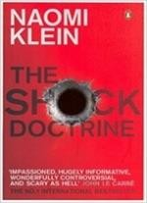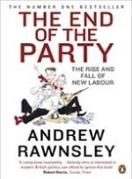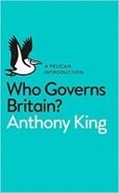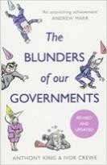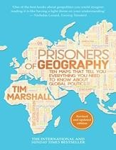
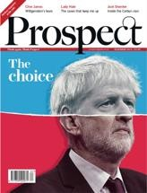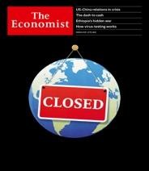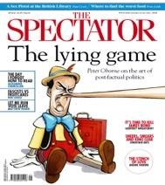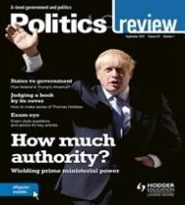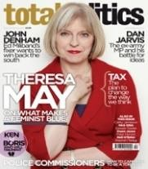

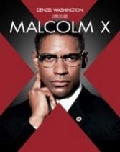

 | Stitcher – A-level politics podcast Beyond Westminster  BBC politics podcasts The Westminster Hour Politics.co.uk podcasts | Guardian ‘politics weekly’ podcasts Going the way of the dodo  10 of the best podcasts Takes from the lobby Learn out loud podcasts

 | iPlayer Climate Change Playlist World economic forum videos Politics Live – BBC iPlayer  The Andrew Marr Show The Politics Show | Question Time BBC Parliament  Cabinet Confidential  Globalisation if Good – Johan Norberg

Career Pathways in Politics:

Top Politics Universities:

Oxford University of Oxford | Course Finder (thecompleteuniversityguide.co.uk)

University College London UCL (University College London) | Course Finder (thecompleteuniversityguide.co.uk)

London School of Economics London School of Economics and Political Science, University of London | Course Finder (thecompleteuniversityguide.co.uk)

Local Universities:

Southampton University University of Southampton | Course Finder (thecompleteuniversityguide.co.uk)

Portsmouth University University of Portsmouth | Course Finder (thecompleteuniversityguide.co.uk)

Politics careers:
